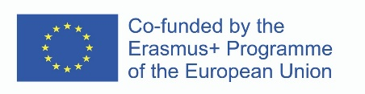
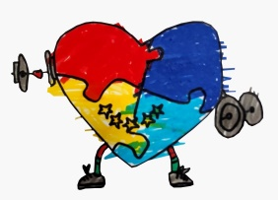
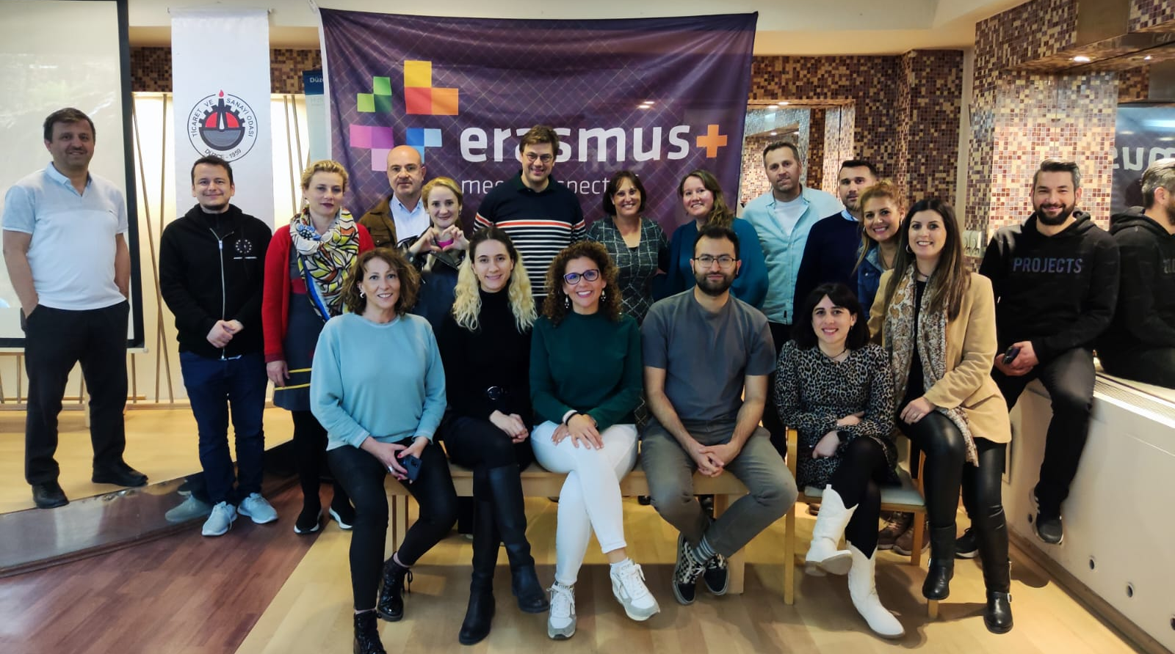
BULLETIN BOARD
Of the Erasmus+ Project
Project Coordinator: Drawing to Health
Partners: Düzce University
Provincial Directorate of National Education of Düzce
İzle Education Center
Ceelasboqueras
Eoepmolina



CONNECT LIFE WİTH SPORTS
Project Reference: 2021-2-NL01-KA220-SCH-000050054

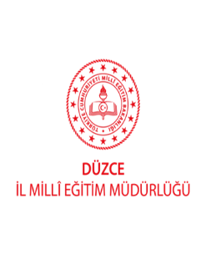
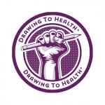
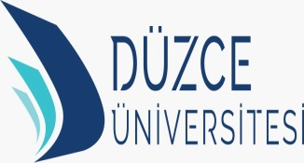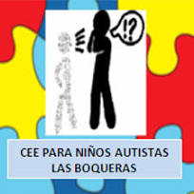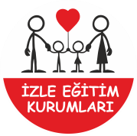

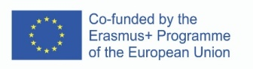
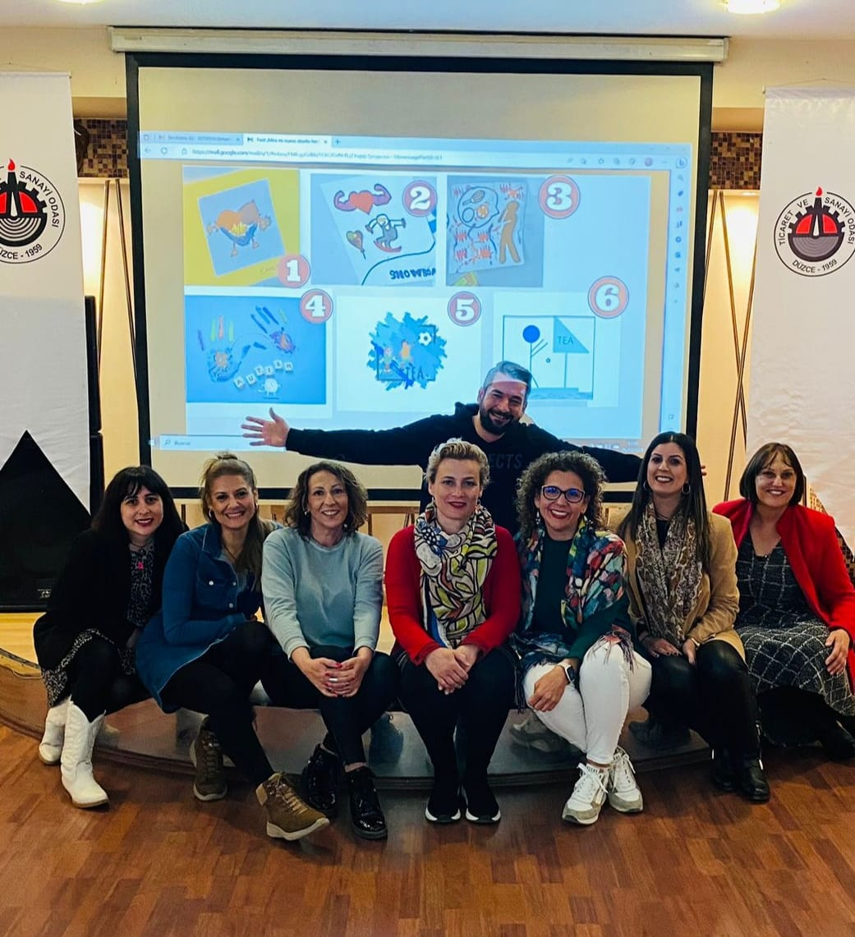
In our first meeting, we chose our own logo from the samples prepared for us by children with ASD in Spain.

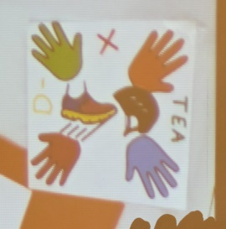
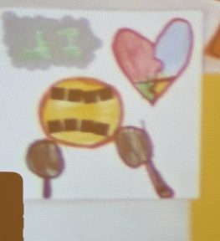

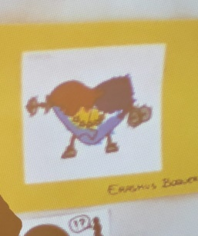

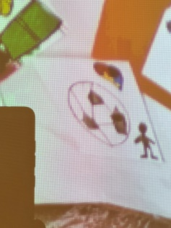

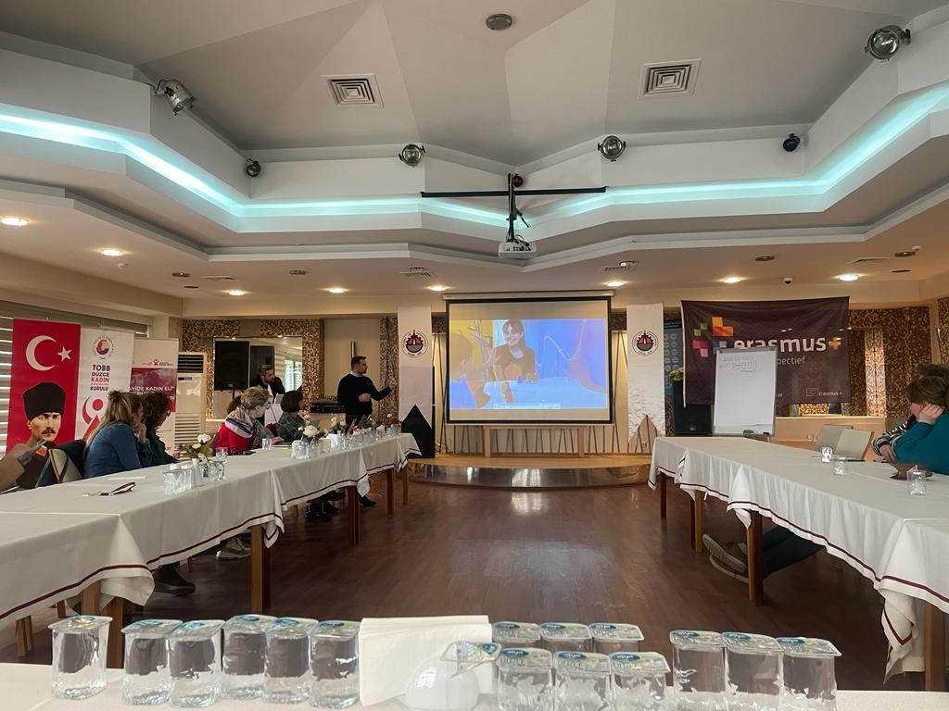

Our meeting continued with the exchange of ideas, accompanied by a presentation by İzle Autism Sports Club, about the main subject of the project, how sports education should be provided for individuals diagnosed with ASD, and the relationship between sports and autism.

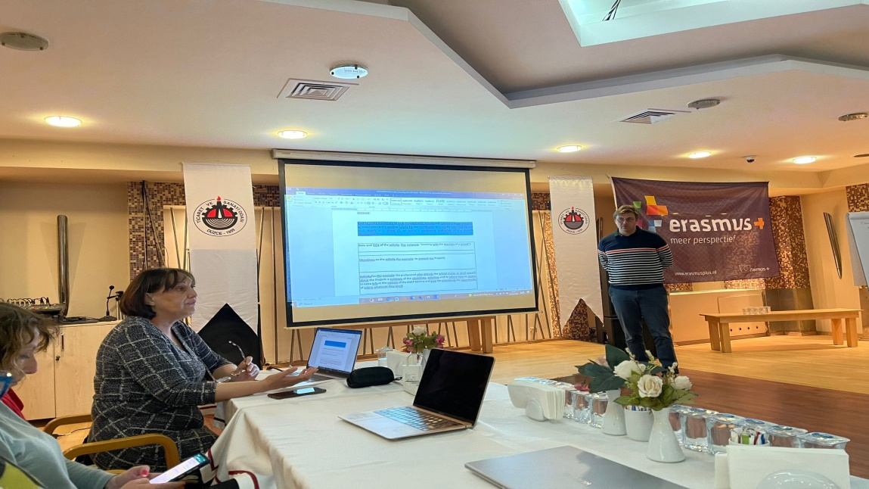

Following the presentations, the date of the next mobility, the Spain mobility, was decided with all partners. The tasks requested from all partners until the Spanish mobility were distributed.

The partners were very happy to have the opportunity to meet face to face for the first time. Türkiye mobility was realized successfully with all partners working in harmony.

See you in Murcia.

