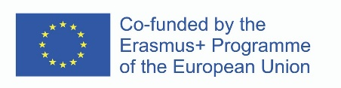
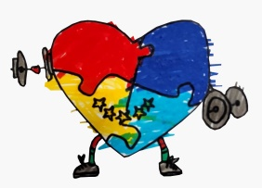
BULLETIN BOARD
Of the Erasmus+ Project
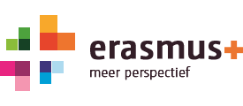

CONNECT LIFE WİTH SPORTS
Project Reference: 2021-2-NL01-KA220-SCH-000050054

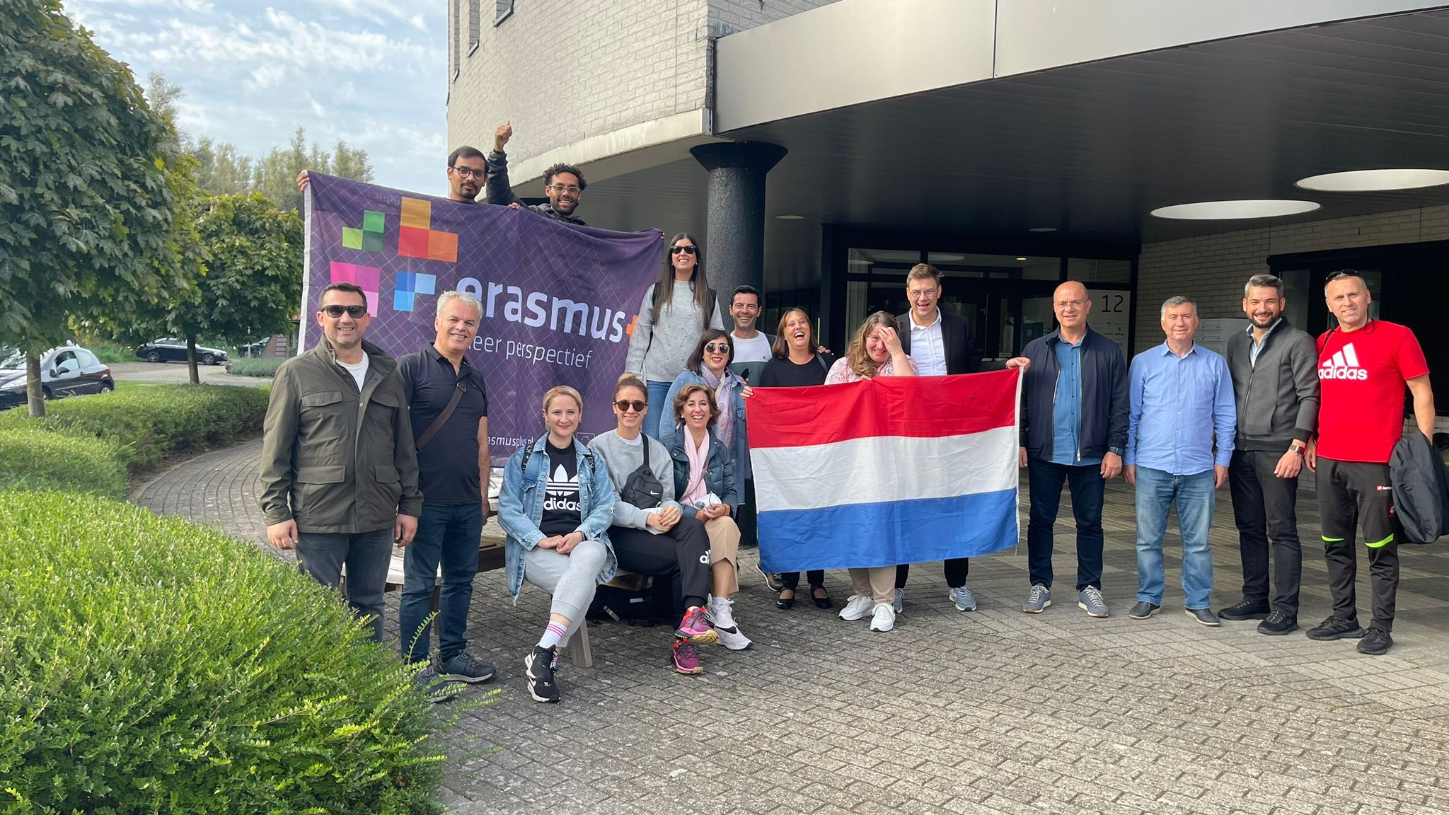

Project Coordinator: Drawing to Health
Partners:
Düzce University
Provincial Directorate of National Education of Düzce
İzle Education Center
Ceelasboqueras
Eoepmolina
The 3rd TPM took place in the Netherlands. The whole team is together again

The excitement of seeing everyone again was great. Everyone had a question in this meeting. There was a common way of creating an educational model on how to teach certain skills to children through sport.

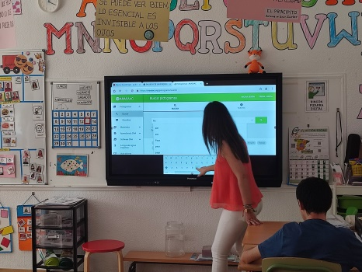

PRACTICING SPORTS IN DEVENTER WAS A GOOD EXPERIENCE FOR US Stanley from the Drawing to Health team took the Türkiye and Spain team and gave us a cycling experience. Together we then practiced movement training in the park.

Duzce University made a presentation about the model of teaching children.
- Direct teaching.
- Indirect teaching.
- Experiential learning.
- Independent study.
- Interactive learning.
- Transferring with pictures.
We received good offers from our team in Spain. They shared about the effect of doing Yogo on children and the motor skills that physiotherapists will create.

For the movement education that we emphasize the most, we have experienced the jumping, balance, hand-eye coordination skills we did in the park and even the bicycle riding skills that we want to teach the children the most. With this meeting, we made a good progress in developing SITUATION, ANALYSIS, PRACTICE

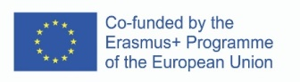

HOPE TO SEE YOU IN TÜRKİYE

Now for the Turkey meeting, partners are starting to select their staff and volunteers to attend the meeting. The Turkey meeting for the training of trainers will be a special excitement for the whole team
In order to share the knowledge and experience we have gained and compiled throughout the project and to multiply it together with you; we are launching the Teacher Experiences Meeting with a meeting in Turkey. The event where we will talk about teacher experiences and inclusive recommendations will be open to everyone.

The Dutch meeting was a good opportunity for us to finalize the handbook.
Everyone will create activities in the handbook and a common model will be created.
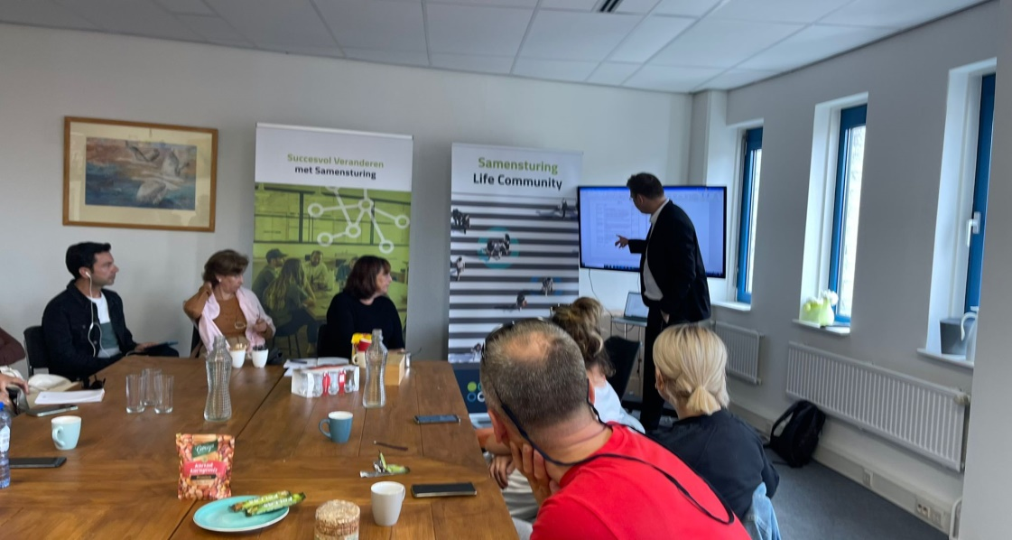

SEE YOU ALL, WE WILL WORK HARD IN TÜRKiYE

